St. Margaret’s Community Church of Scotland Dunfermline
38 Garvock Hill, KY12 7UU
Iain Greenshields, Tel: 07427477575
Email: revimaclg@hotmail.co.uk

24th January 2021 Newsletter
Things are not always as they seem to be. Here is one example:
The daughter of the famous atheist Bertrand Russell says that her father’s whole life was a search for God. “Somewhere at the back of my father’s mind, at the bottom of his heart, in the depths of his soul, there was an empty space that had once been filled by God, and he never found anything else to put in it.”
In Russell’s own words “There is a darkness without and when I die there will be a darkness within.”
To many people Russell was a confident atheist but inwardly that was clearly not the case either to himself or his nearest and dearest!
What do we take from that?
If we listen to many in the modern scientific community, they discard or even rubbish faith – faith that is precious to us.
Philip Yancey was once on a panel of 5 people, three of whom were scientists of some note – all three had been Nobel Prize winners in physics and all were atheists. Yancy wondered how to address his audience and his three “opponents”. He suggested that there were three important questions that science could not answer and belonged only to the realm of faith.
- Why is there something rather than nothing?
- Why is it that the Universe is so beautiful and orderly; especially our earth?
- How ought we to conduct ourselves in such a world?
The scientists, after much discussion agreed that there were limits to what science can answer.
In our culture today, we assume that people quite simply to do not believe. We do not think that people are searching either for meaning or for God. That is a huge assumption based on the fact that when we look around, so few people show such little interest in the Church.
Well, of course, it may be that it is we who show such little interest in those around us. Just because our Church doors are open and a sign outside says that all are welcome, does not mean that we have done all we can to build the bridge between us and them!
Now is the time for us to build relationships and friendships with people who do not have faith – this is the mission of the Church in the 2020’s and beyond. I believe that there are many, like Russell, who have an inner emptiness and yearning that only the Gospel can fill – they are lost and they do not know where to go.
Jesus went out to find lost people, not expecting them to come to him – remember the story of the lost sheep in Luke’s Gospel? We need to get back to becoming “fishers for people” as Jesus called his first disciples and not gatekeepers of a building which is what many have become.
Iain
Intimations
Services will be at the normal times on Sunday – Facebook will go on at 9am, Zoom at 9.45.
Zoom Service on Wednesday at 6.45pm where we are looking at the life of St. Paul. This is a series of reflections by Con Campbell with the filming shot in situ.

HYMN VERSES
Our chosen verse for this week comes from someone who wants to remain anonymous.
Our verse this week comes from hymn 485, Dear Lord and Father of Mankind; the chosen verse is number 5

Drop thy still dews of quietness
Till all our strivings cease;
Take from our souls the strain and stress,
And let our ordered lives confess
The beauty of thy peace.

“This verse was chosen because it has helped me time and again during lockdown to get perspective and peace.”
[If you have a verse from a hymn you would like to offer – even anonymously – just drop me a note or an email.]

“Yesterday is history, tomorrow is a mystery, today is a gift of God, which is why we call it the present.”
― Bill Keane

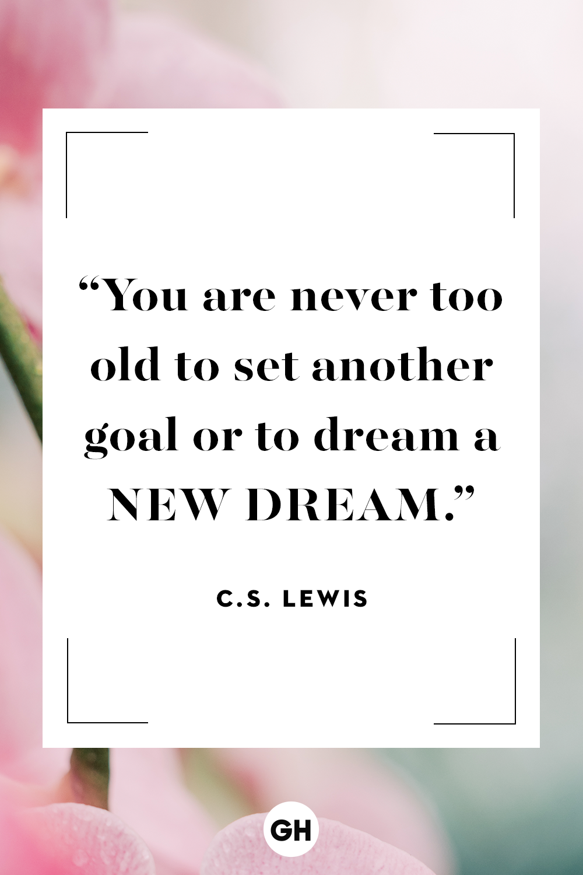
“It is never too late to be what you might have been.”
― George Eliot

“When one door of happiness closes, another opens; but often we look so long at the closed door that we do not see the one which has been opened for us.”
― Helen Keller

“Success is not final, failure is not fatal: it is the courage to continue that counts.”
― Winston S. Churchill

“Never doubt that a small group of thoughtful, committed, citizens can change the world. Indeed, it is the only thing that ever has.”
― Margaret Mead

